FSDI 106 – Final Report
Name: Charles Taggart
Theme: Task Manager Web System
GitHub Pages Link: https://github.com/chucktagg83/project106.git
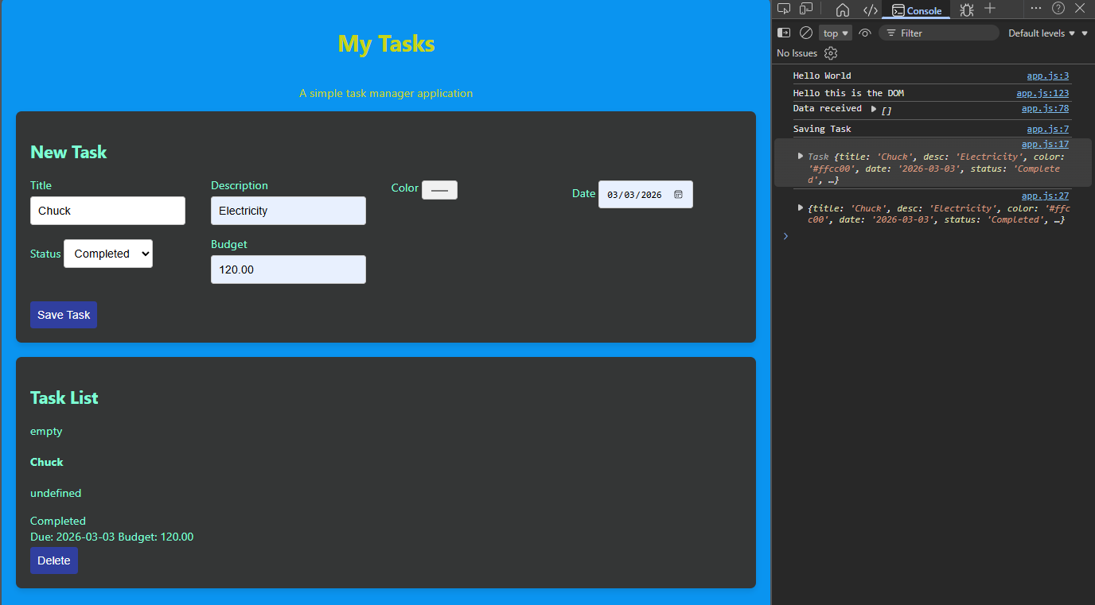
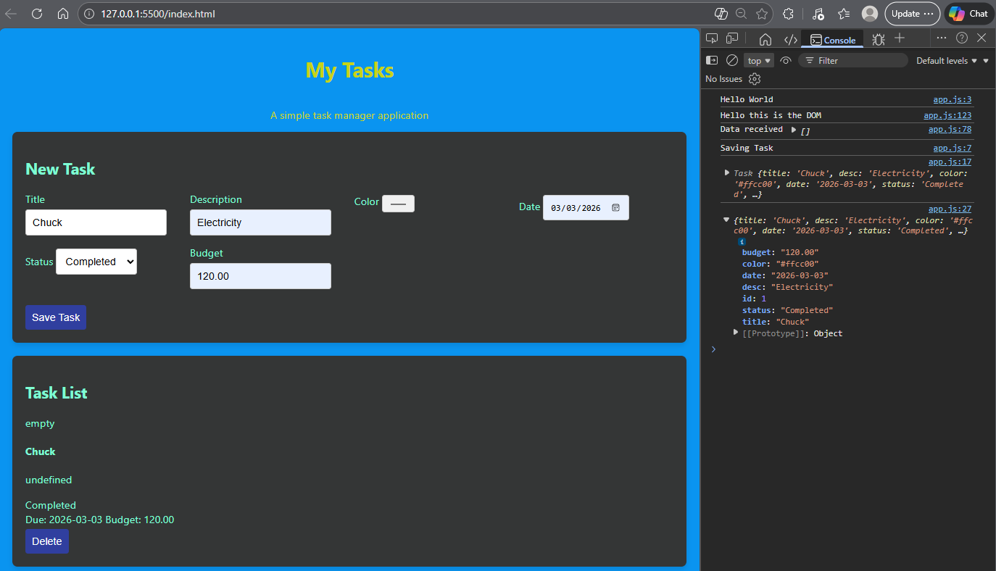
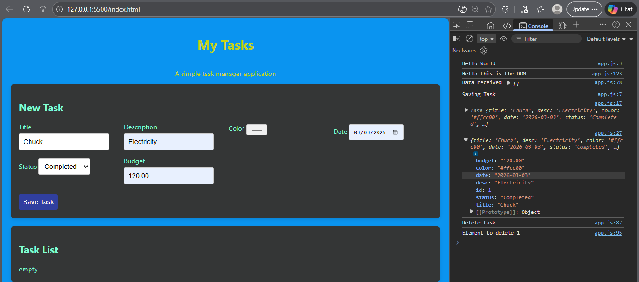

Summary of Edits:
- Uses jQuery for event handling
- Retrieves the list of tasks using an HTTP request
- Displays the information on the screen
- Has a working Delete button

